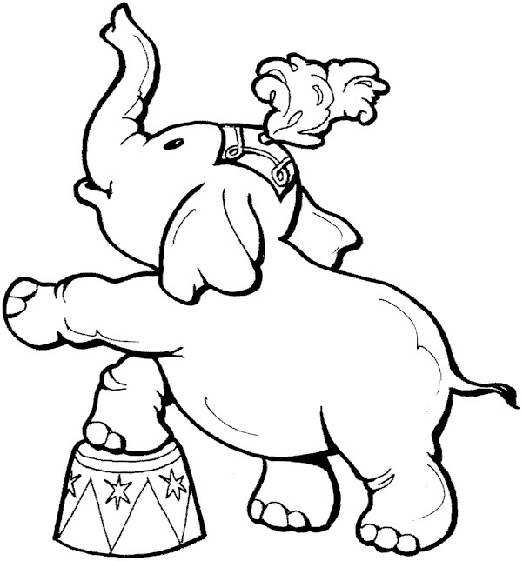

I´m an elephant Bobo. I´m grey. I live in a circus but I come from Africa. I am big, fat and heavy. I´m very strong too. I´ve got a big head and big ears. I´ve got a long trunk. I´ve got four short legs and a short tail. I like leaves, vegetable and fruit. I don´t eat meat. I love water. I can dance and say hello.

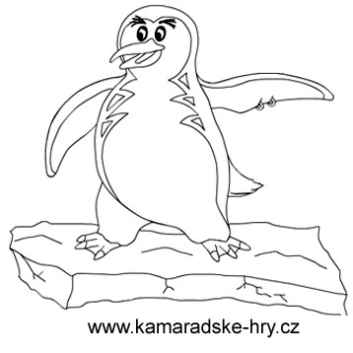

I´m Penguin. I live in the North Pole. I´m small. I´m black and white. I´ve got two short legs and two
wings. I like water. I can sim very well but I can´t fly. I eat fish. I don´t like fruit or vegetable.
I don´t like hot places.
http://omalovanky-k-vytisknuti.ic.cz

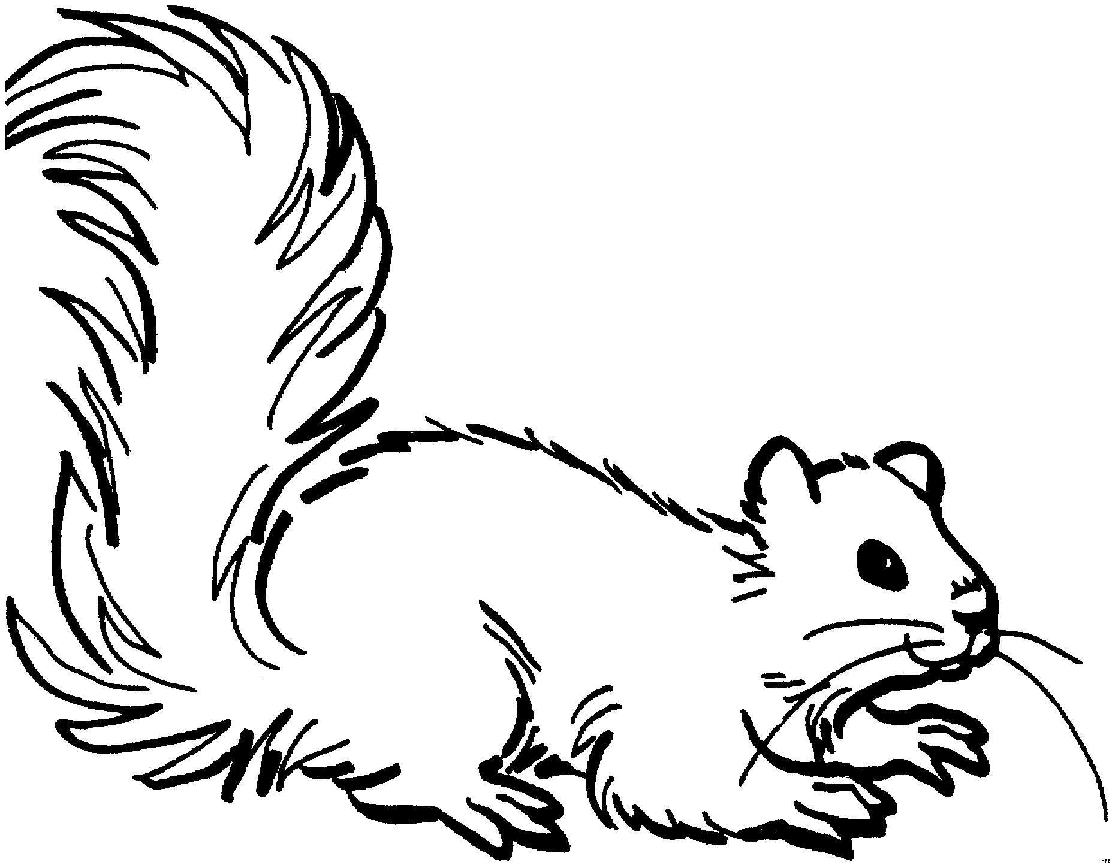

I´m a squirrel. I live in a forest. I am small and brown. I´ve got four short legs. I´ve got a big tail. I´ve got very strong teeth. I like nuts. I can jump a climb the trees. I don´t eat meat.

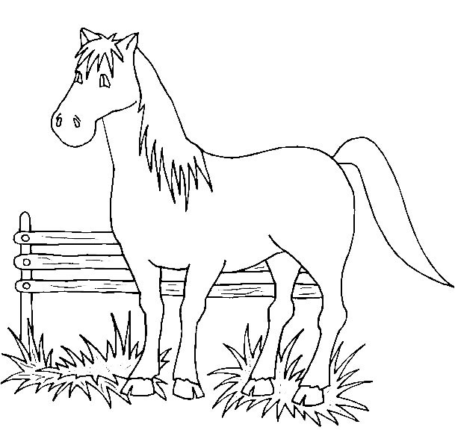

I am a horse. I´m brown with white ears. I live on the farm. I am big and nice. I´ve got four long legs and a long tail. I can run very fast. I can jump and swim. I eat grass, vegetable or fruit. I don´t eat meat. I like sugar.

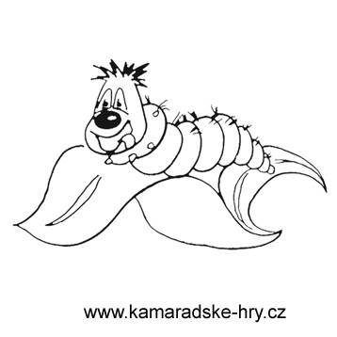

I am a caterpillar. I´m green and small. I haven´t got any legs or a tail. I like leaves. I don´t eat meat. I live in the garden. I can climb the leaves. I can´t swim or jump. I´m very humry.

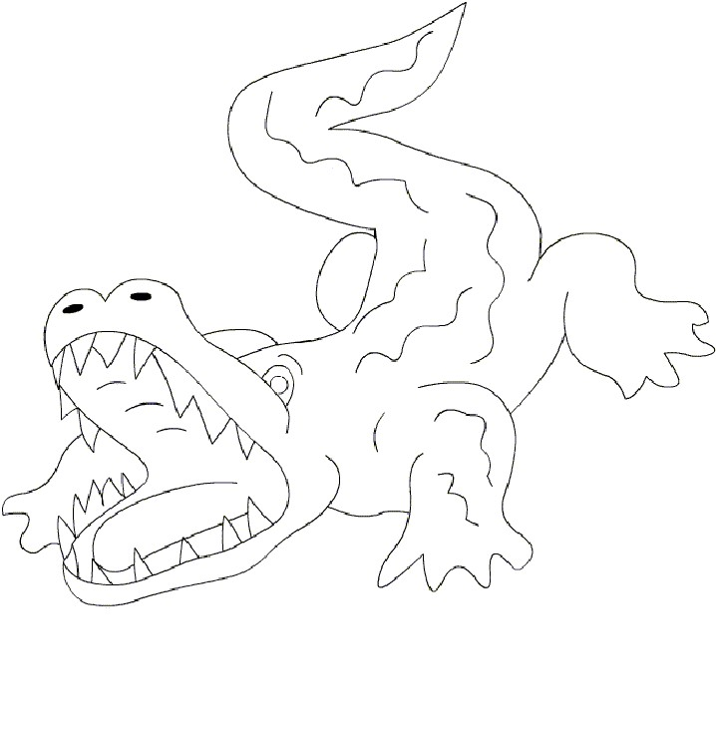

I´m a crocodile. I´m green. I´ve got four legs and a big tail. I´ve got a big mouth and many teeth. I´ve got very strong teeth. I like meat. I don´t eat grass, fruit or vegetable. I can swim but I can´t jump. I live in a river.

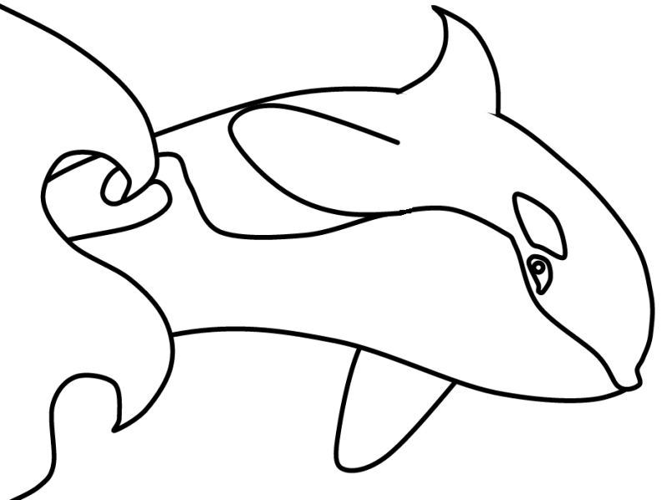

I am a whale. I live in the sea. I´m very big. I´m black and white. I´ve got no legs. I can swim and jump very well. I eat fish. I like meat. I don´t eat vegetable or fruit. I´ve got a big mouth. I haven´t got any ears.

Pracovní list

Odpověz na následující otázky:
What is your animal? _______________________________________________________
Where does it live?_________________________________________________________
What does it eat?__________________________________________________________
What can it do?____________________________________________________________
How does it look? __________________________________________________________
What colour is your animal?__________________________________________________
Can it swim?______________________________________________________________
Does it like meat? __________________________________________________________
Has it got four legs? ________________________________________________________
Is it a big animal? __________________________________________________________

Přepiš věty z puzzlů do 3. osoby j.č.:
Např: I live in Africa – It lives in Africa. I don´t eat meat – It doesn´t eat meat.

Zeptej se dvou spolužáků na jejich zvíře a vyplň tabulku podle informací, které získáš.
Animal 1 Animal 2
It is …

It lives ….

It has got …

It eats…..

It doesn´t like …

It can …..

Návod k použití učebního materiálu:

Šablony zvířat vytisknout a pro větší trvanlivost zalaminovat a rozstříhat na puzzle.
Puzzle rozdáme žákům. Ti se snaží puzzle složit a z vět na jednotlivých dílcích se dozví pár informací o svém zvířeti. Následně vypracují úkoly dle zadání na pracovním listě.
Další aktivitou může být hádání jaké zvíře mají spolužáci. Hádající se táže tak, aby spolužák odpovídal jen ano nebo ne dokud neuhádne, jaké zvíře má.

Použité materiály:
http://omalovanky-k-vytisknuti.ic.cz

